Auto Responders
Build a scheduled release of materials to customers in your opt-in list. Auto-responders add in the possibility of producing timed campaigns that routinely galvanize customers with evenly spaced increments of offers and text updates.

Create a Special “Drip” for Customers
From the day that the user opts in, their auto-response messages will come in the same lengths of time that any other user who has opted in. This creates an organized flow or “drip” of information. The drip could be an exercise program, daily tips or advice, anything you want!
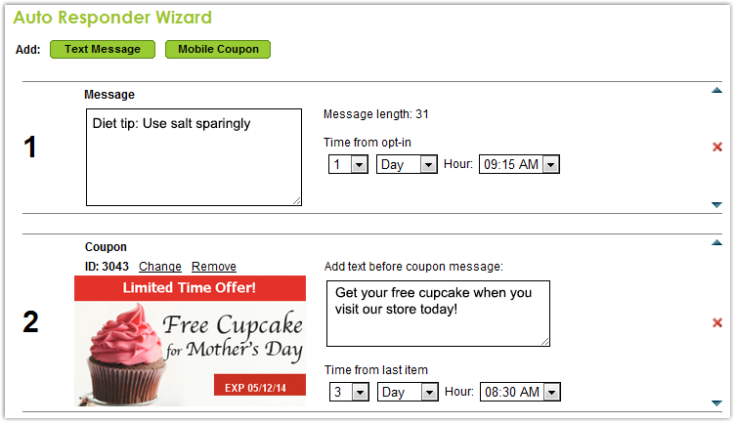

Message Intervals
Fix the individual messages/coupons to be sent by number of days after the first message, or within a certain number of days after any other message you have scheduled. For instance, a user gets a coupon to a gourmet food store 4 days from the day that they opt in, and three days from the day the coupon was sent they receive a schedule for cooking classes and instructions on how to sign up!

